1. Steps to run the project after download.

* If you are getting below error after start the project in debug mode.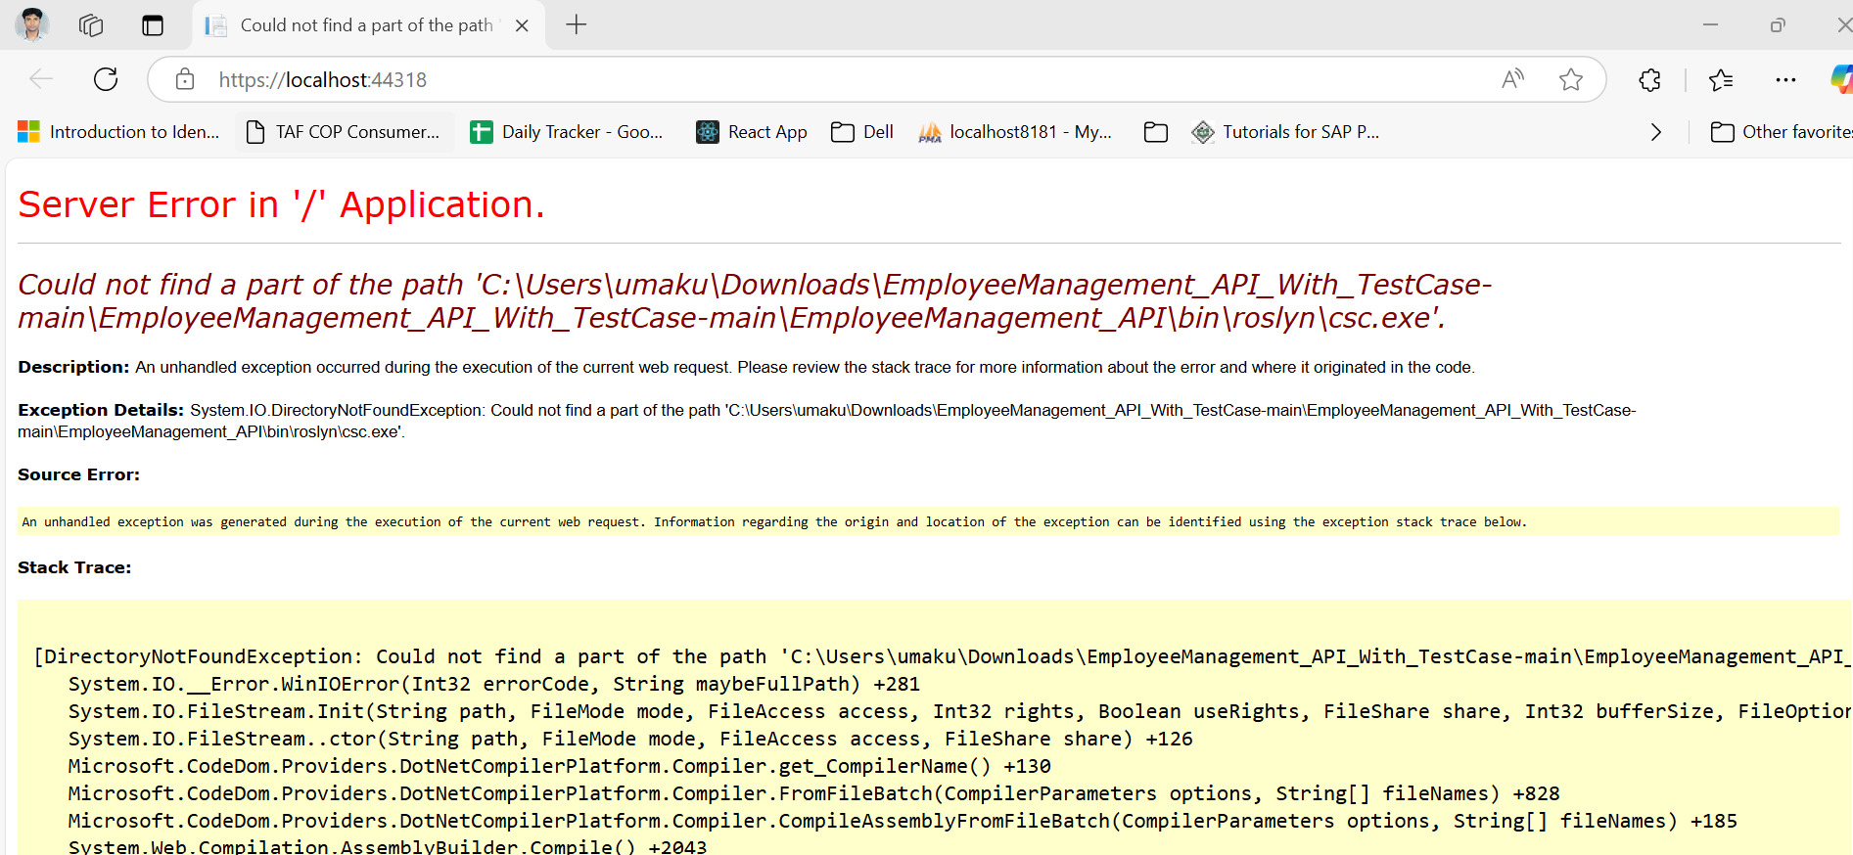

Note – Run below command on **Package Manager Console –**

Uninstall-Package Microsoft.CodeDom.Providers.DotNetCompilerPlatform

And after that run -

Install-Package Microsoft.CodeDom.Providers.DotNetCompilerPlatform

* After installation finish.

Build the project and Run again and you will get help screen, you can click to see list of API available on this project by clicking on API Menu.

Note – Further you can use that API as per documentation by Postman Application.

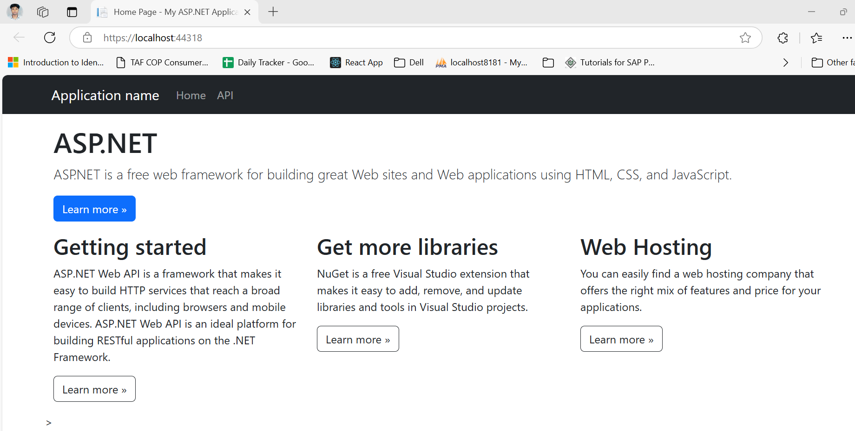

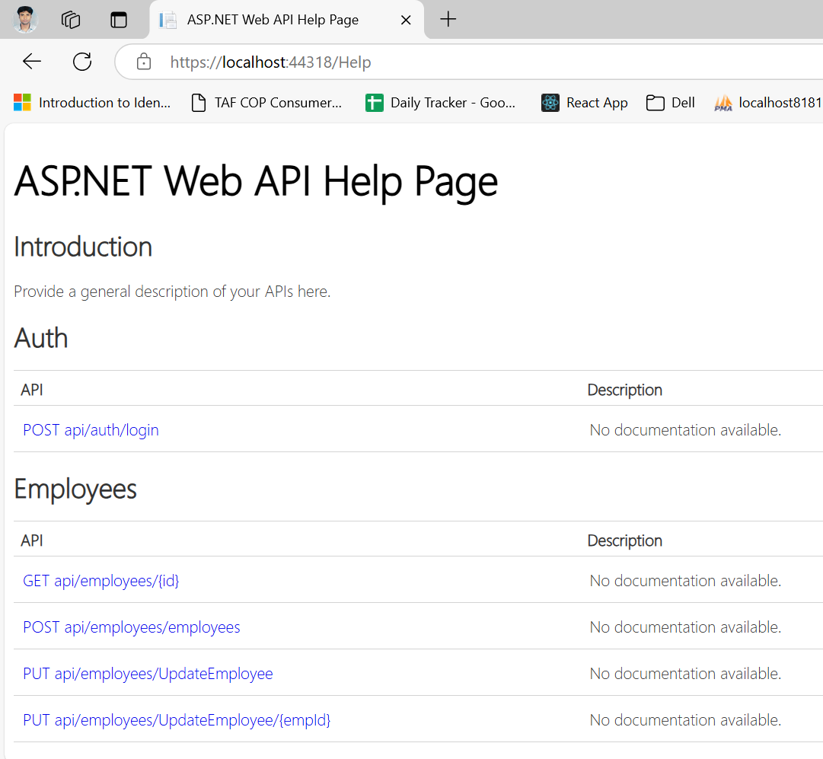

* If required further information please refer below –

use method

-------------------------------------------------------------------

--https://localhost:44318/Api/employees/UpdateEmployee

--Update Employee - PUT Method

{

"Id" : 1,

"Name" : "Kunal Kumar",

"Email" : "kunalumarsingh@gmail.com",

"Position" : "IT Manager",

"Salary" : 5000.00,

"DepartmentId" : 1

}

--------------------------------------------------------------------

--Create new employee-

---https://localhost:44318/Api/employees/employees

{

"Id" : 2,

"Name" : "Uma Kumar",

"Email" : "umakumarsingh@gmail.com",

"Position" : "Manager",

"Salary" : 5000.00,

"DepartmentId" : 1

}

---------------------------------------------------------------------

Update Employee by ID and Employee Model

---https://localhost:44318/Api/employees/UpdateEmployee/2

{

"Name" : "Sonoo Kumar",

"Email" : "sonookumarsingh@gmail.com",

"Position" : "HR Executive",

"Salary" : 10000.00,

"DepartmentId" : 1

}

--Get Employee By Department ID -

https://localhost:44318/Api/employees/GetEmployeesByDepartment/1

----------------------------------------------------------------

--Get Department By Id

https://localhost:44318/Api/departments/1

--Get All Departments

https://localhost:44318/Api/Departments/GetAllDepartments

--Create Departments

https://localhost:44318/Api/Departments/departments

{

"id": 1,

"name": "HR",

"description": "HR Department Manage all resource."

}

--Delete Department

--- https://localhost:44318/Api/Departments/DeleteDepartment/4

--UpdateDepartment/{deptId} "HttpPut"

--https://localhost:44318/Api/Departments/UpdateDepartment/4

put data of departments

{

"name": "Admin",

"description": "Admin Department Manage all IT, HR Stuff."

}

* Migration Code – for Package Manager Console

Add-Migration migration_name

Update-Database